**In This Guide**

|  |  |
| --- | --- |
| * Initiate a Animal Order for multiple types under single protocol | * Create templates accessible through Favoritese |

**Procedure**

1. From the **Home/Shop** screen, select the **Investigator Order Form** link from the **Showcased Services** section of the screen.  
     
   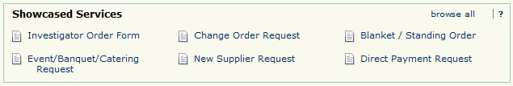
2. The Investigator Order form appears in a new window.



***Review the ordering instructions on the left hand side of the form, as they contain important information related to fulfilling your request.***

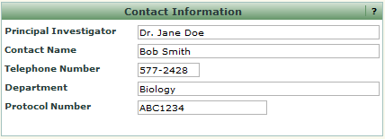

1. Populate the **Contact Information** section of the form with the appropriate information for the requesting parties. Fields with bolded descriptions are required.
2. Repeat the same process for the **Animal Specifications** section of the form.
3. Populate the **Order Information** section of the form. Utilize the links to supplier websites located on the right hand side of the form to determine pricing for the requested specimens. Enter accurate price estimates in the **Unit Price** field.
4. Select the **Add to Cart** option from the **Available Actions** dropdown box and then click the  icon. The request has been added to your shopping cart, but all the information is retained. You can now use the form as a template. Make any changes to the specifications, sex, price estimate, etc. and **Add to Cart** again. Repeat as many times as necessary. *(Note: this should only be used when the Protocol remains the same. A separate requisition should be submitted each protocol.)*
5. Select the  icon to view the contents of your cart. The Animal order request is displayed. You can click the 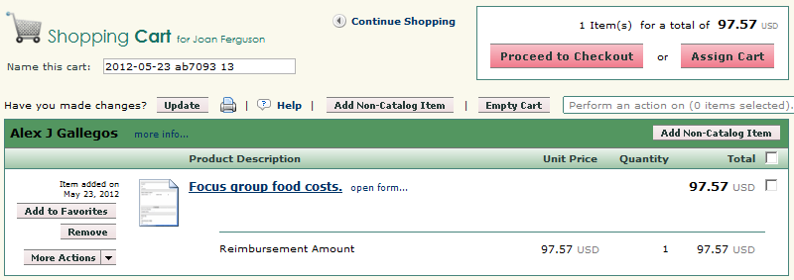 icon and forward the draft cart to a department requisitioner (if applicable) for final processing OR proceed to step 8.From the
6. **Shopping Cart** screen select the icon within the existing to add a line item to capture estimated shipping costs.

Do not use

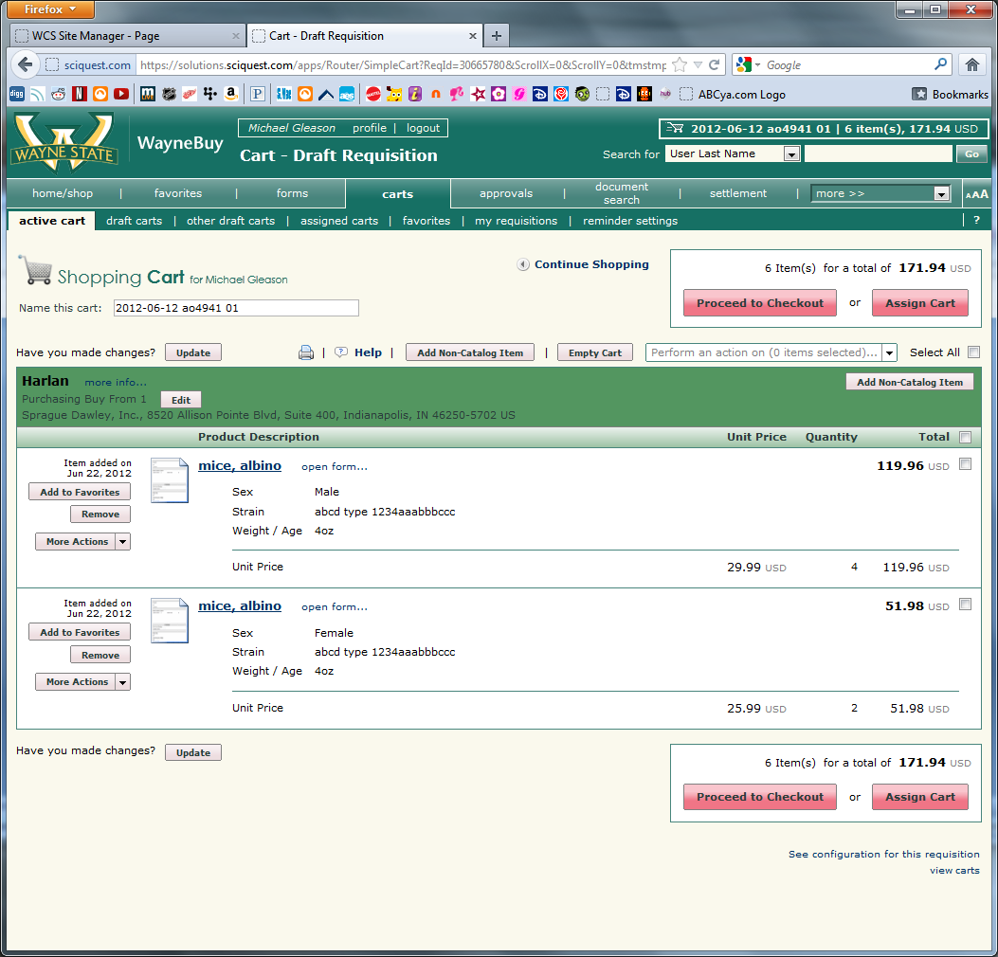

***Adding a line item for estimated shipping and handling allows approvers to have full visibility of the total cost   
of the order prior to approving the request.***



1. Enter *Estimated Shipping and Handling Costs* in the **Product Description** field. In the **Quantity** field, enter 1. In the **Price Estimate** field. *(Please note: this will give the DLAR Procurement Specialists a defined dollar threshold to proceed with your order requests. If the final order amount is outside of this estimate, DLAR will confirm the higher price with the department prior to order issuance.)* From the **Commodity Code** field, select the *Scientific Equipment; Maintenance Contracts; Supply Items; Repairs* value. Select the icon.

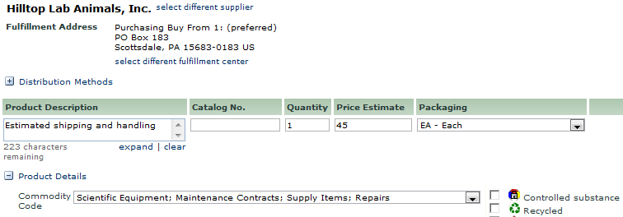

1. Select the icon. The **Requisition Summary** screen is displayed.
2. Select the  process step or click the **Accounting** tab under the Requisition window (shown below).   
     
   
3. Select the  icon for line item containing the Animal Order. A pop-up window will appear with the existing accounting information for the requisition line (or entire requisition if so selected). Select the link for the **Index** field OR enter your 6 digit **Index** (in known already) and skip to step 16.  
     
   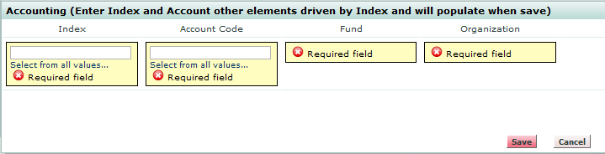
4. A search box is displayed. Enter search criteria in either the **Value** or **Description** fields and select the  icon.
5. 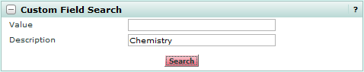

1. A list of search results is returned. Select the link next to the appropriate index value.

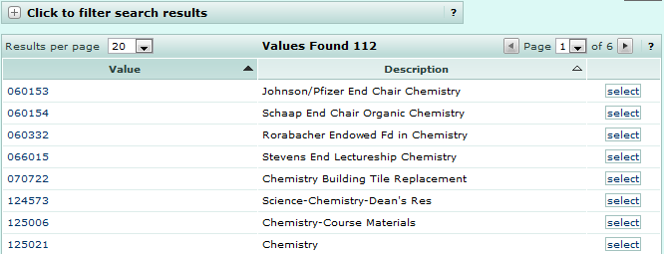

1. The Accounting pop-up box is updated with the selected index value.



***Selecting an Index value will automatically populate the Fund, Organization, Program, Activity, and Location fields. Index and Account Code are the only two fields users are required to populate on a requisition.***

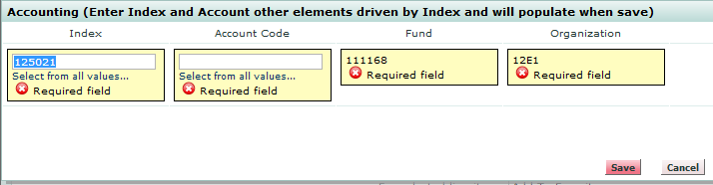

1. Enter in 721Y5 for the **Account Code** field and click the 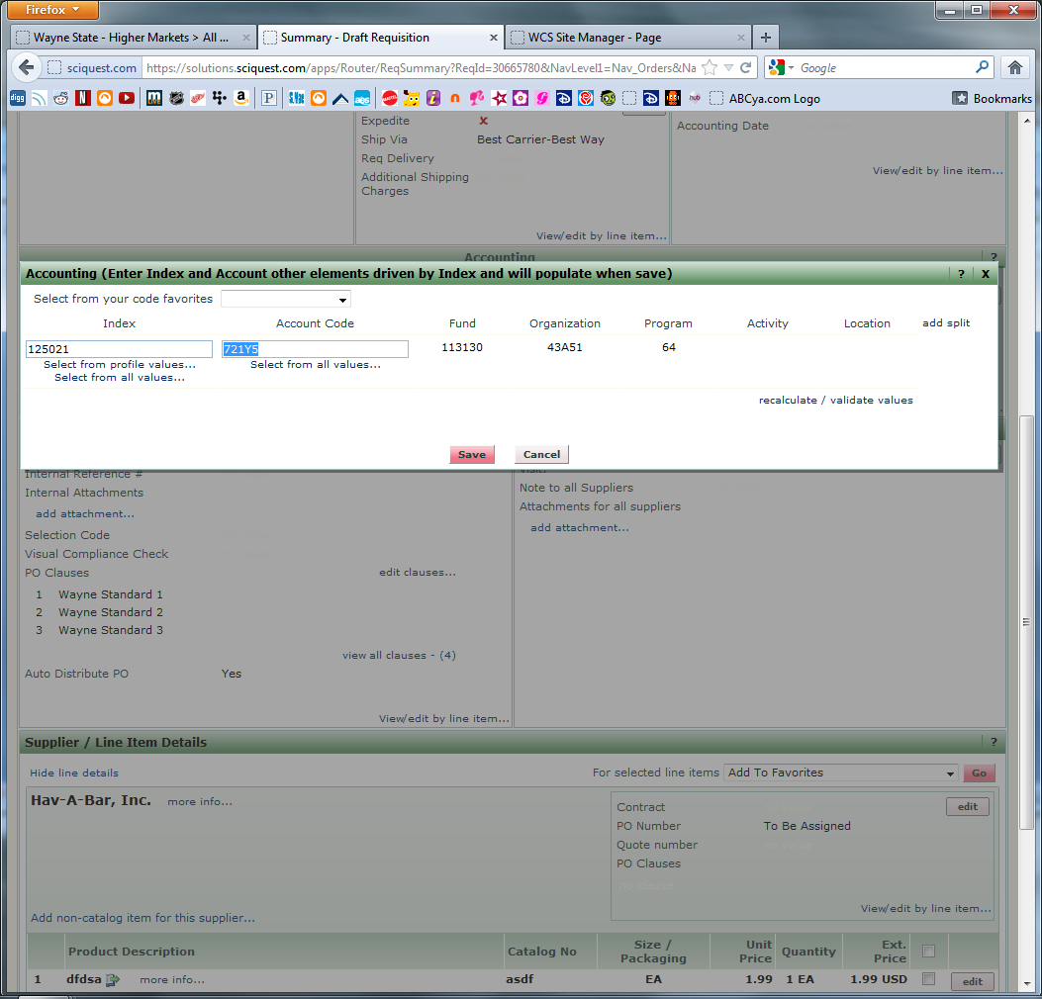 icon.  
     
   
2. Select the  process step and review the information contained on the request. Make any required changes.
3. Click the 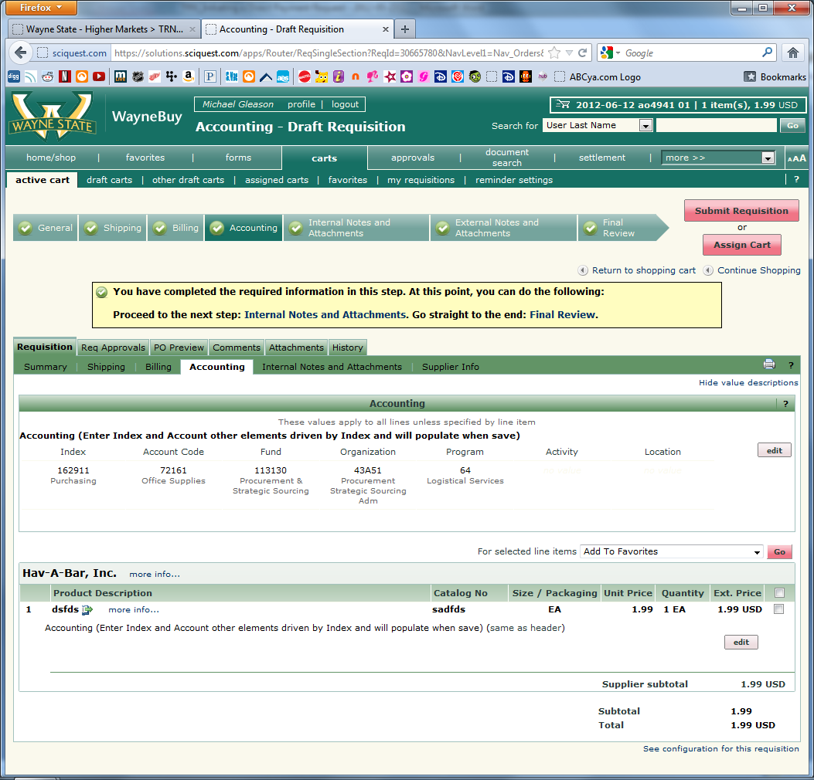 icon. The request is submitted into the workflow and a confirmation message is displayed containing the unique identifier of the request.  
     
    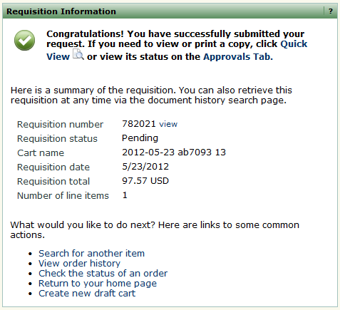

***When completing the form you also have the opportunity to “Add to Favorites” under the Available Actions link. This will allow you to save the request as a template for future use. Please contact the Procurement Office for a walkthrough @ (313)577-3734.***

